|  |  |
| --- | --- |
| **[Assignment / Project] – External Document** |  |
| COMP6176 | COMP6232  Human and Computer Interaction |
| [Odd / Even / Compact] Semester Year 9999/9999 |

* Project Title

Del Luna Store

* Introduction

**Store Del Luna** is a famous 1st hand K-Pop merchandise supplier established in June 2013. We provide original K-Pop albums and merchandises from many artists.

With the growth of information technology, **Store Del Luna** plans to dive into the world of digital business. First, **Store Del Luna** must create a **logo** and **company** **website** that represents **Store Del Luna’s** image. With this website's existence, **Store Del Luna** hopes they can improve their service towards their customers. **Store Del Luna** entrusts you as a web designer to design and create their **logo** and **company** **website**.

* Report / Documentation

1. Del luna Logo



We design the logo to be simple modern, but eye catching. The logo consists of Del Luna name, a Korean word meaning store and crescent moon representing the store name which literally mean moon.

1. Home Page

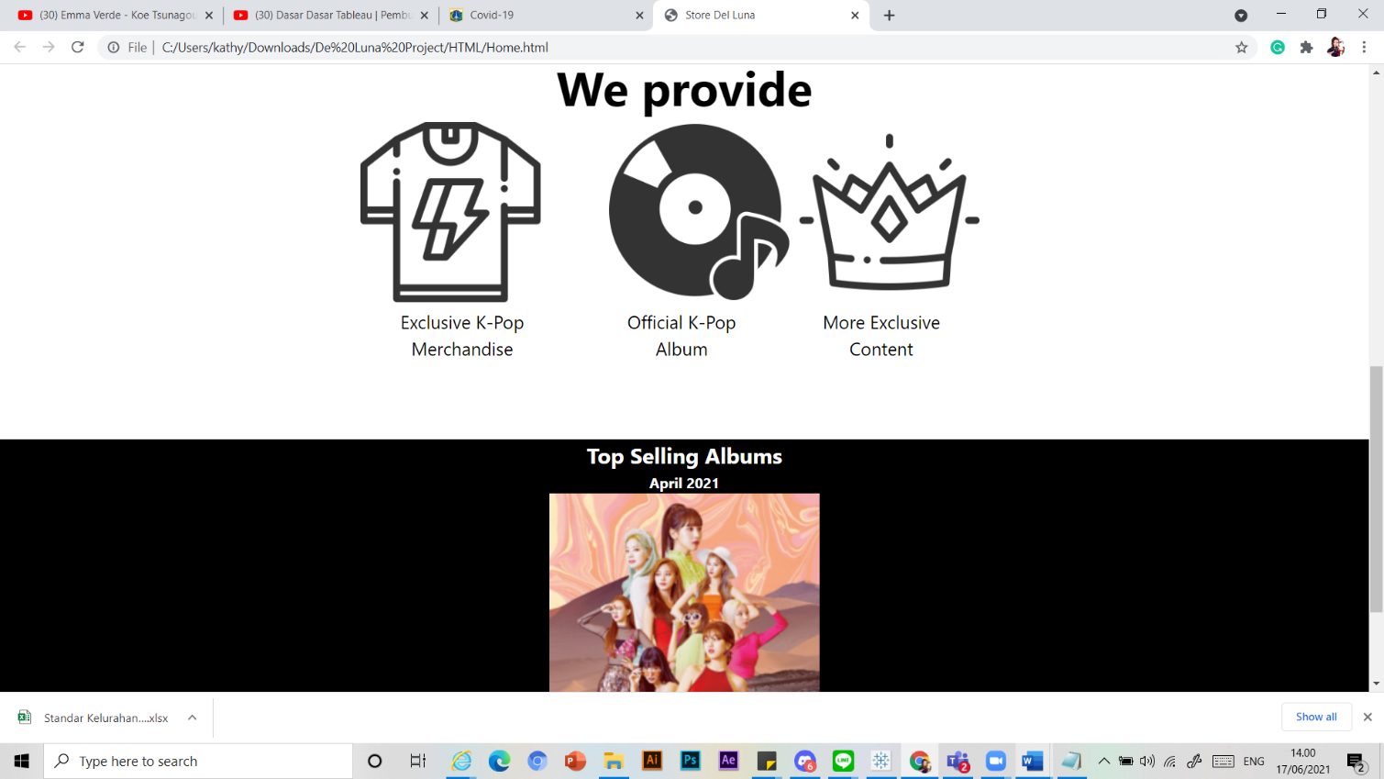

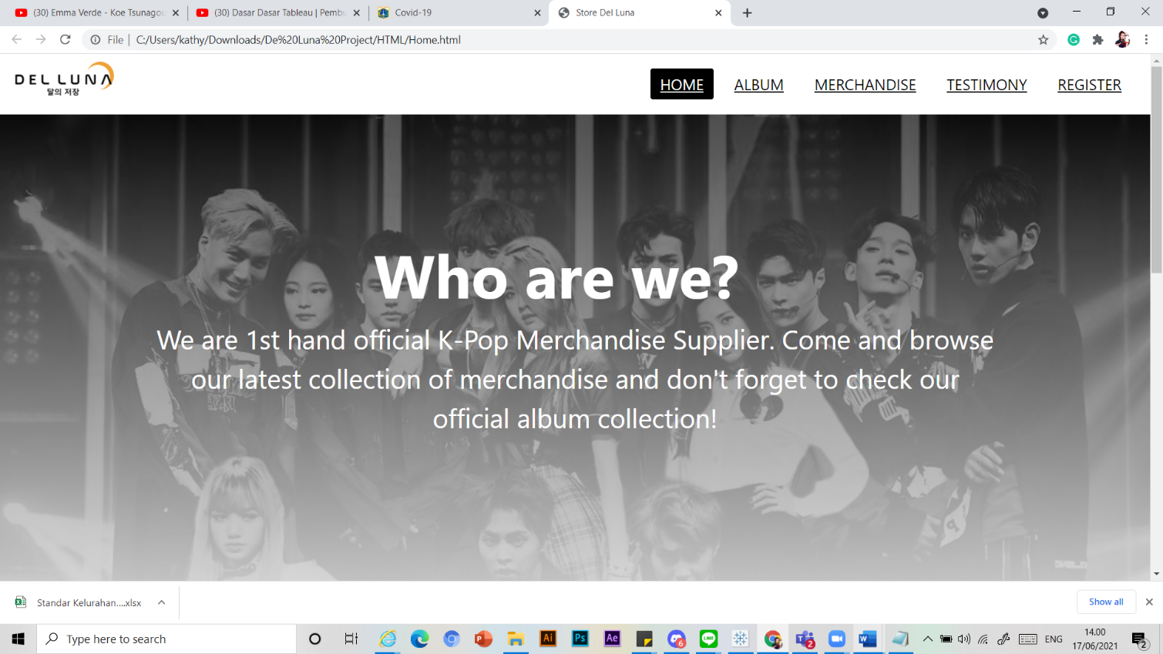The home page consists of about the website (who are we?), what the website provide (we provide), and the top selling album of April 2021 which is made in form of image slider. There is also navigation bar and footer. (Terdapat menu dinavigation bar untuk mengarahkan ke section website lainnya.)

1. 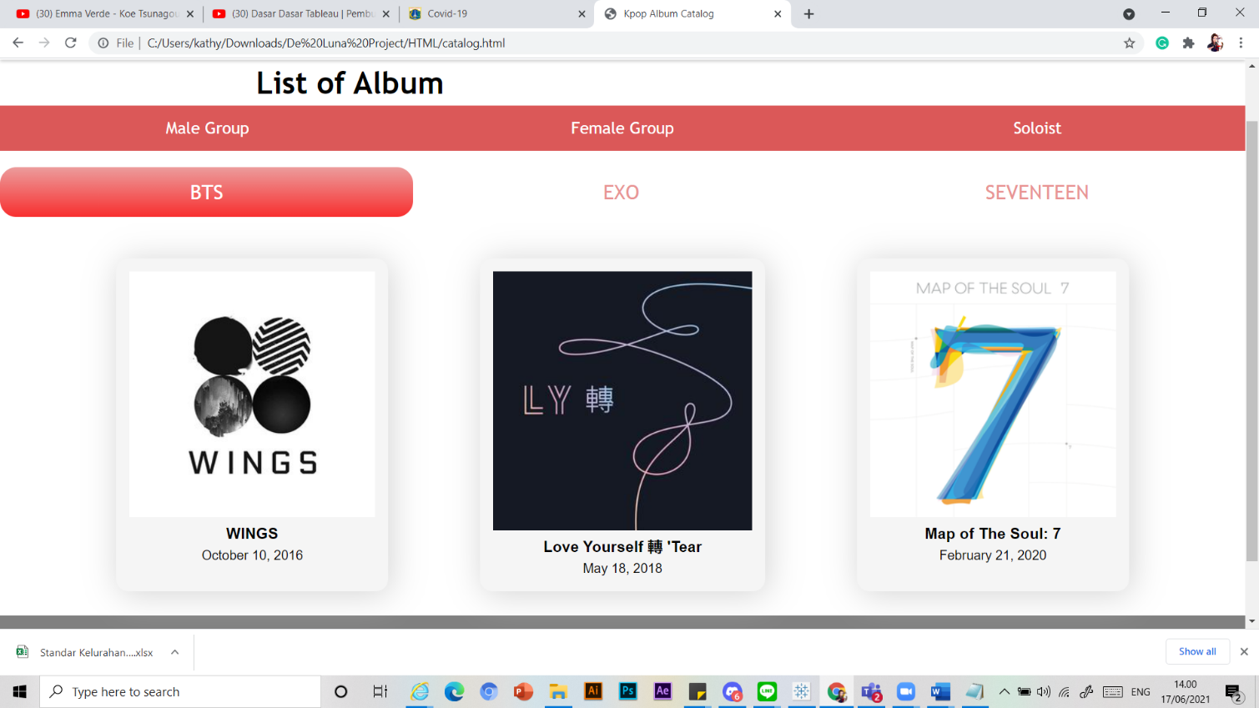Album Page

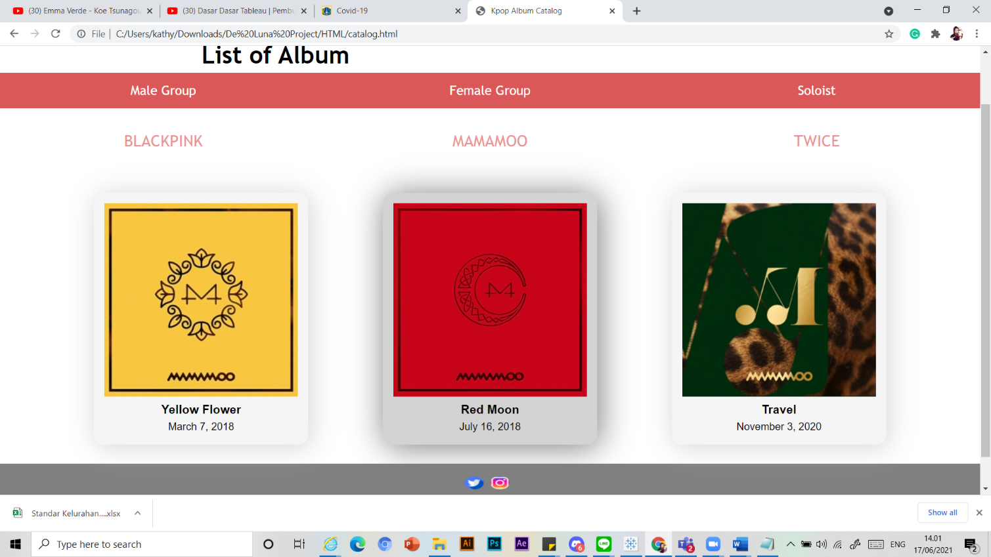

The album page consists of categories of K-Pop groups. When you click the category, there will be the name of the groups pops up in the screen. If you choose the name of the group, it will then pop up the albums of the chosen group.

1. Merch Page

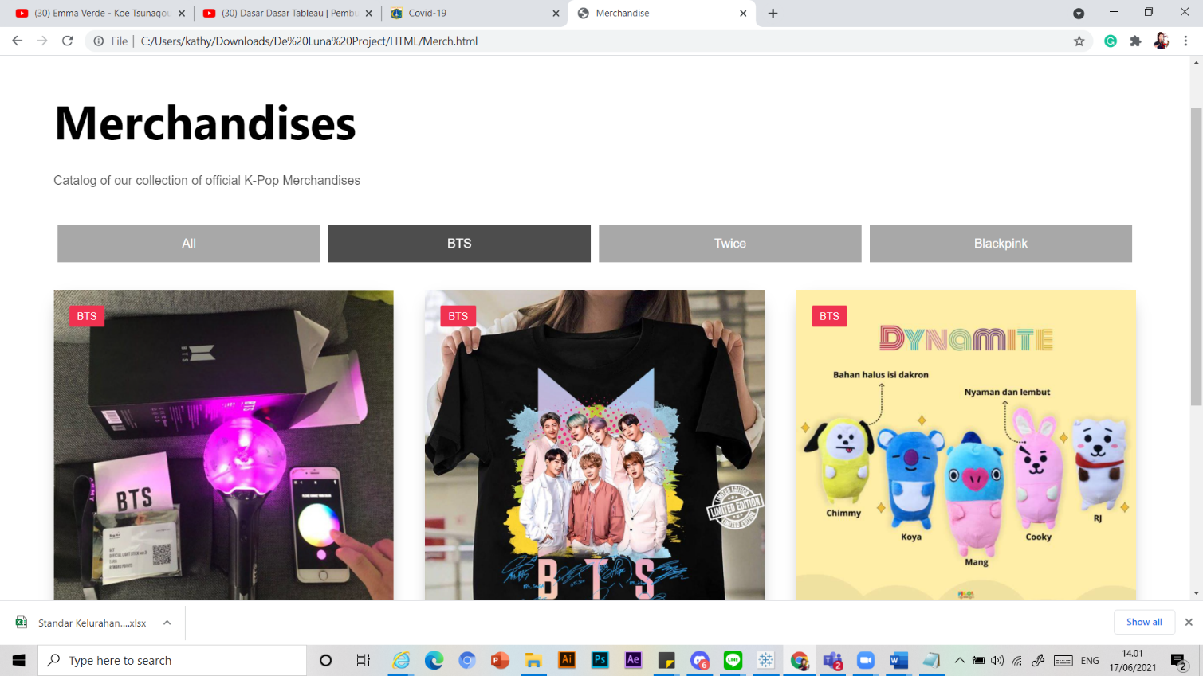

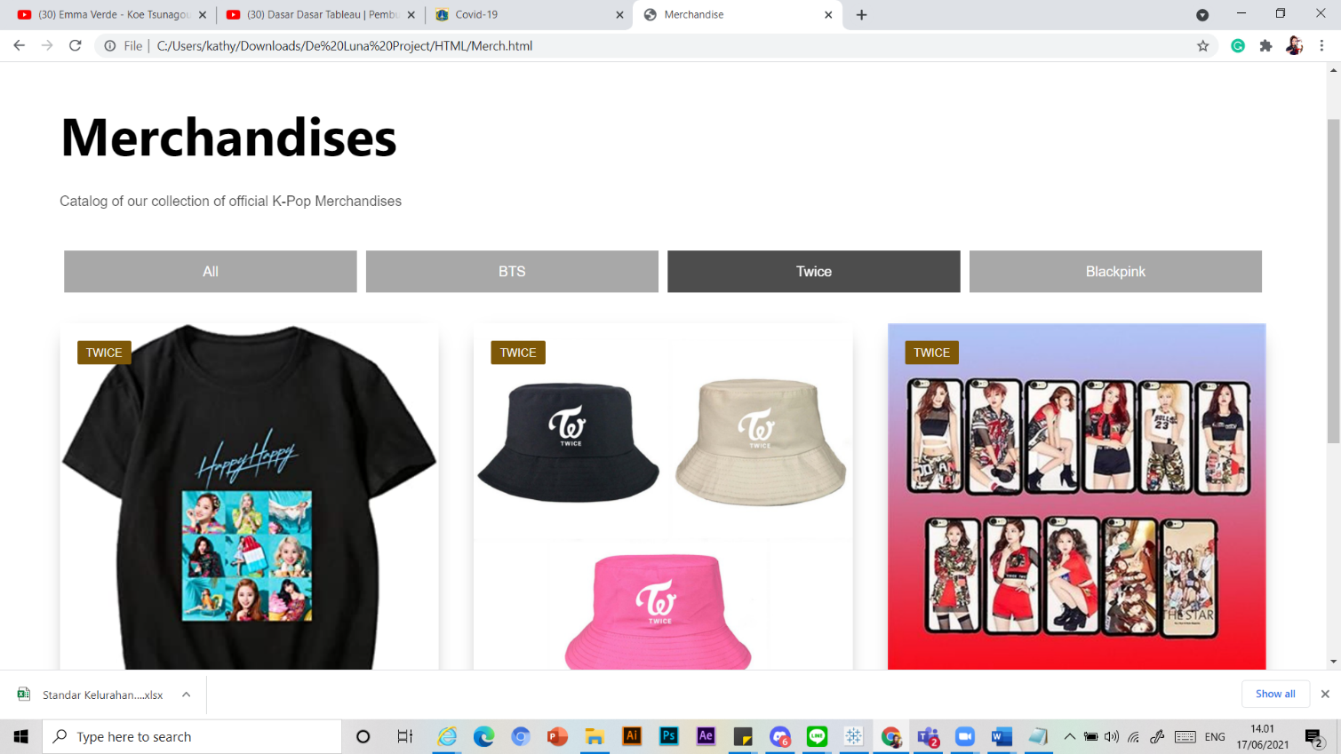

The merchandise page is consisting of categories of merchandise the website have. There is also label in each merchandise showing which group the merchandise belongs to. If you click on the category, it will filter out only merchandise that belong to that certain group.

1. 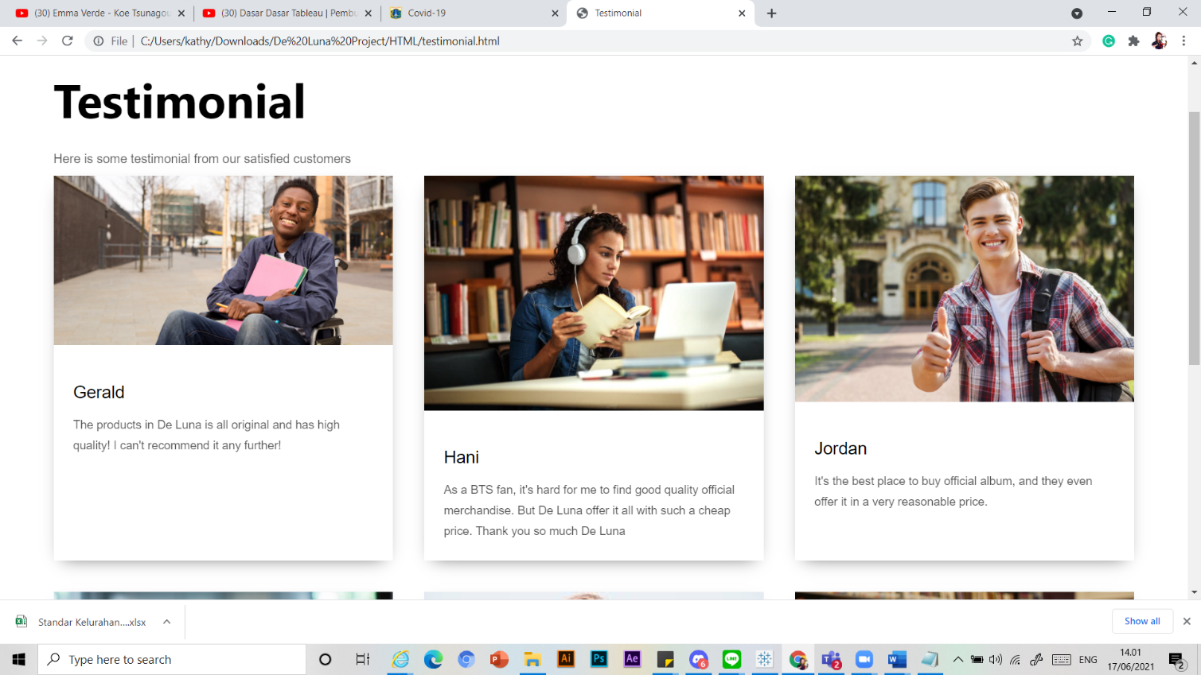Testimonial Page

The testimonials page consist boxes of our customer’s testimonial.

1. 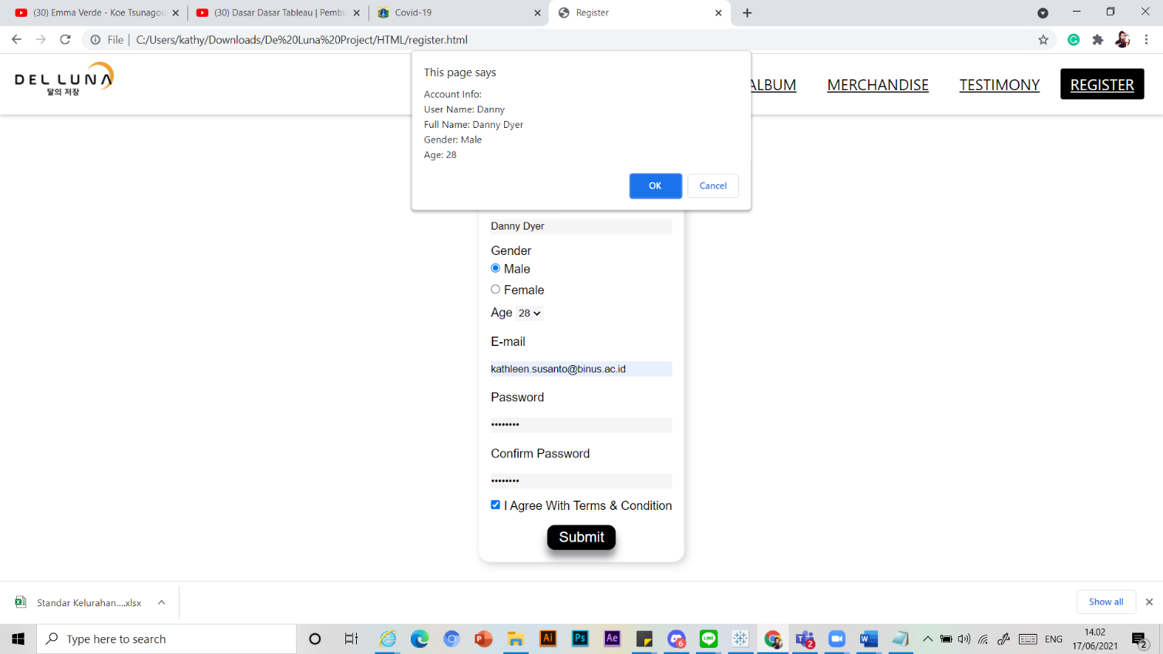Register Page

The register page is a form that every guest has to fill. Each part has its own validation, and if the validation failed, it will put out warning and if it’s successful, it will show notification in the picture above.

Reference

* *Home Page
* Twice album: https://en.wikipedia.org/wiki/Fancy_You_(EP)
* Rose Album: https://www.liputan6.com/showbiz/read/4507438/rose-blackpink-cetak-sejarah-lewat-album-solo-perdana
* BTS Album: https://ibighit.com/bts/eng/discography/
* Header Background:https://tr.pinterest.com/pin/731835008193461957/
* Sosmed and we offer icons taken from flaticon.com
* *Album Page
* 01. https://upload.wikimedia.org/wikipedia/en/3/3f/BTS%2C_Wings.jpg
* 02. https://upload.wikimedia.org/wikipedia/en/8/88/Love_Yourself_Tear_Cover.jpeg
* 03. https://upload.wikimedia.org/wikipedia/en/2/21/BTS_-_Map_of_the_Soul_7.png
* 04. https://upload.wikimedia.org/wikipedia/en/c/c7/ThewarEXO.jpeg
* 05. https://upload.wikimedia.org/wikipedia/en/5/58/Exo_%E2%80%93_Don%27t_Mess_Up_My_Tempo.png
* 06. https://upload.wikimedia.org/wikipedia/en/e/e8/Exo_-_Obsession.png
* 07. https://upload.wikimedia.org/wikipedia/en/1/11/Seventeen_-_Al1.png
* 08. https://upload.wikimedia.org/wikipedia/en/8/82/You_make_my_day_seventeen_artwork.png
* 09. https://upload.wikimedia.org/wikipedia/en/5/51/Henggarae_seventeen_artwork.png
* 10. https://upload.wikimedia.org/wikipedia/en/f/f8/Square_One_-_Blackpink.jpg
* 11. https://upload.wikimedia.org/wikipedia/en/2/26/Black_Pink_-_Square_Up_artwork.png
* 12. https://upload.wikimedia.org/wikipedia/en/f/f2/BLACKPINK-_The_Album.png
* 13. https://upload.wikimedia.org/wikipedia/en/f/fb/Yellow_Flower_EP.jpg
* 14. https://upload.wikimedia.org/wikipedia/en/f/f0/Red_Moon_by_MAMAMOO_cover.jpg
* 15. https://upload.wikimedia.org/wikipedia/en/6/65/Mamamoo_-_Travel.jpg
* 16. https://upload.wikimedia.org/wikipedia/en/1/16/Twice_%E2%80%93_What_Is_Love%3F_cover.jpg
* 17. https://upload.wikimedia.org/wikipedia/en/3/33/Twice_-_Feel_Special.png
* 18. https://upload.wikimedia.org/wikipedia/en/3/33/Twice_-_Eyes_Wide_Open.jpg
* 19. https://upload.wikimedia.org/wikipedia/en/b/b6/IU_Palette_final.jpg
* 20. https://upload.wikimedia.org/wikipedia/en/4/41/IU_-_Lilac.png
* 21. https://upload.wikimedia.org/wikipedia/en/f/ff/Warning_Sunmi.png
* 22. https://upload.wikimedia.org/wikipedia/en/f/fc/Sunmi_-_Tail.png
* 23. https://t2.genius.com/unsafe/750x0/https%3A%2F%2Fimages.genius.com%2F70fc402fe83d7220379f7ff6e3ec8dfa.680x680x1.jpg
* 24. https://t2.genius.com/unsafe/750x0/https%3A%2F%2Fimages.genius.com%2Ff0839adc6b859349d46c49d2ed23b49e.1000x1000x1.jpg
* *Merch Page
* BTS
* 1. Boneka dynamite -> https://www.blibli.com/p/bantal-boneka-bt21-telur-bantal-bts-merchandise-bts-bahan-halus-isi-dakron-tm239-bantal-telur-bts/pc--MTA-8959921
* 2. T-shirt -> https://lancometee.com/trending/bts-new-version-signatures-shirt/
* 3. Lightstick -> https://shopee.co.id/-READY-STOCK-Official-BTS-Army-Bomb-Ver.3-Lightstick-Light-Stick-ver3-i.80247534.1850949320
* Twice
* 1. Phonecase -> https://twicemembersprofile.blogspot.com/2021/04/kpop-twice-merchandise.html
* 2. T-Shirt -> https://www.amazon.com/Xkpopfans-Twice-T-Shirt-Album-Tshirts/dp/B07VML3CH4
* 3. Hat -> https://shopee.ph/Twice-Bucket-Hats-Adult-Cotton-Wide-Brim-Flat-Top-Fisherman-Hat-i.49648872.1724172958
* Blackpink
* 1. Hoodie -> https://www.desertcart.id/products/248597853-kpop-blackpink-hoodie-cat-ear-sweater-jennie-jisoo-rose-lisa-sexy-crop-top
* 2. T-shirt -> https://www.tokopedia.com/noonanyanct/blackpink-in-your-area-t-shirts-official-thirts-blackpink-t-shirt-kaos
* 3. Plushie -> https://web.facebook.com/permalink.php?id=698366507018202&story_fbid=1446091195579059&_rdc=1&_rdr
* *Testimonials
* 1. https://binakarir.com/career-preparation-for-disability-college-student/
* 2.https://www.clevergirlfinance.com/blog/college-student-credit-card-debt/
* 3.https://emanhafez.org/college-student-thumbs-up-e1440734712137/
* 4.https://perfectbeauty.id/beautytalk/makeup-anak-kuliahan-apa-saja-produk-yang-perlu-dibeli/asian-college-student/
* 5.https://online.maryville.edu/blog/exercise-and-nutrition-for-college-students/
* 6.https://plexuss.com/news/article/how-to-be-a-successful-college-student

Group Member

* 2301854340 – Tony Harris Hung
* 2301870110 – Kathleen Febiola Susanto
* 2301952773 – Ryani Yuan Jie Lee